TKP Lesson 1:

Objects, Methods and For Loops

# Part 1 - Recipe: Simple Square

# Part 2 – Recap: Simple Square

[**http://lfal.co/RecapSimpleSquare**](http://lfal.co/RecapSimpleSquare)

# Part 3 – Variation: Simple Square

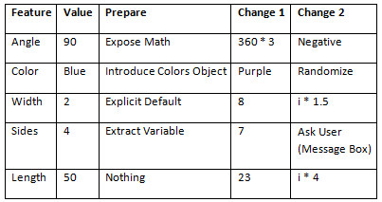

*Suggestion: Use “Snipping Tool” and Print out Students’ Variations to take home.

# Part 4 – Quiz:

SimpleSquareQuiz.java

# Part 5 – Deep Dive:

Homework01.java

# Part 6 – Worksheet:

SimpleSquareWorksheet.docx

# Part 7 – Solo Recipe: Spiral